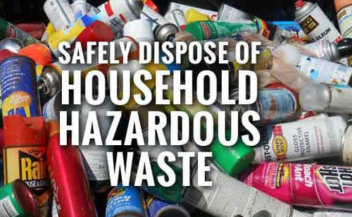
2022 TOX AWAY DAY EVENT
Montgomery County Solid Waste Management District
SATURDAY, JULY 9, 2022
8am – 1pm
North Montgomery High School
Tox Away Days: What You Should Know
1) They are very popular & well-attended. As such, sometimes the lines for Tox-Away Days can be long. But, don’t let that scare you away! The lines typically move quickly with most visitors getting through in under ten minutes.
2) We are there, rain or shine. Indiana weather is fickle, regardless of the forecast or what might be falling from the sky; we will be there on Tox Away Day. There have been instances when severe weather has necessitated us pausing the line so our workers could seek shelter. If that happens, rest assured that we will resume the event when it is safe to do so and will get everyone taken care of.
3) Don’t bring latex paint. We ask residents not to bring latex paint to Tox-Away Day. Why? Because latex paint is a water-based substance and it is non-hazardous. Drying Instructions: Dry out latex paint by removing the lid, mixing paint with equal parts of cheap kitty litter, sand, oil dry, or shredded newspaper. The paint should dry to a solid form in a couple days. Set the dried paint out for trash pick-up with the lid removed.
4) No heavy trash, please. Items such as mattresses, furniture, scrap metal, flooring and construction debris, etc. should not be brought to Tox Away Day for disposal. We also are not set up to receive traditional recyclables like bottles, cans, newspaper and cardboard during the events.
5) Stay in your vehicle & let us do the work. We Hoosiers are helpful & hard working by our nature. However, when it comes to Tox Away Day, it is better for everyone if you stay in your vehicle and let us do the unloading. The fact is, it helps keep the lines moving faster. Once one person gets out to help unload, then others begin to do the same thing-all that shifting, unbuckling, door opening, walking, chatting, walking, door closing, re-buckling and shifting takes time…
If you have questions about what’s accepted or anything else related to Tox Away Day feel free to contact us:
MONTGOMERY COUNTY SOLID WASTE MANAGEMENT DISTRICT
Office: 765.361.2623
Email: mcswmd@montgomerycounty.in.gov

