2023 TOX AWAY DAY EVENT
MONTGOMERY COUNTY SOLID WASTE MANAGEMENT DISTRICT
SATURDAY, JULY 8, 2023 - 8:00 AM TO 1:00 PM
NORTH MONTGOMERY HIGH SCHOOL
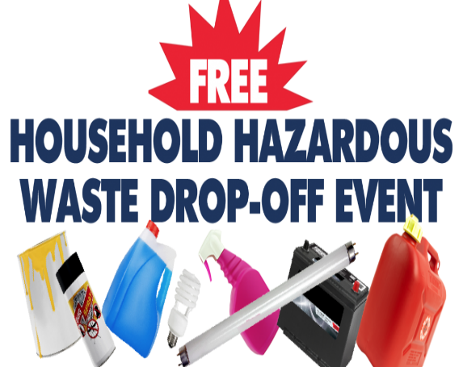

Tox-Away Days - Acceptable Materials
Tox-Away Days are collection events where Montgomery County households can properly dispose of chemicals, fluids, bulbs, batteries, tanks, medical sharps, tires, electronics, appliances and more. A complete list of the items and materials accept is below.
THE FOLLOWING ITEMS SHOULD NOT BE BROUGHT TO TOX AWAY DAY:
**Water-based paints (dry it up and throw it out, here’s how below)**
Latex paint is water based and non-hazardous. Remove the lid and dry out latex paint, mixing paint with equal parts of cheap kitty litter, sand, oil dry, or shredded newspaper. The paint should dry to a solid form in a couple days. Set the dried paint out for trash pick-up with the lid removed. Liquid paint is not accepted by most trash haulers.

- Documents to shred (we do not offer shredding services on Tox Away Day)
- Heavy trash items (furniture, mattresses, construction material, etc.)
- Traditional recyclables (bottles, cans, plastics, paper, cardboard, etc.)
- Alkaline Batteries - AA/AAA/C/D/9V/Etc. are Non-Hazardous
- Asbestos, lab chemicals, explosives, ammunition, firearms, radioactive material, or infectious material.

**Only cash or check will be accepted for payment**

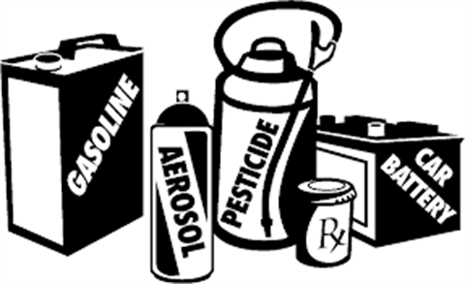

HOUSEHOLD HAZARDOUS WASTE

Oil-based Paints/Stains/Varnishes
Pesticides/Herbicides/Fertilizers/Insecticide
Fluorescent Light Bulbs (tubes and CFL’s)
Automotive Fluids/Fuels/Antifreeze/Oil Filters
Pool/Spa Chemicals
Adhesives
Acids
Drain Openers
Cleaners/Solvents
Mercury-containing Items (Thermometers, Thermostats)
Fire Extinguishers
Propane Tanks
Batteries: Auto & Rechargeable
Sharps (lancets, syringes, etc.; must be in a rigid
puncture-resistant container)

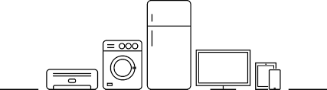

LARGE APPLIANCES
Refrigerators
Freezers
Dehumidifiers
Stoves
Washers
Dryers
Microwaves
Air Conditioners
**Small, hand-held appliances should be disposed of in your normal trash.

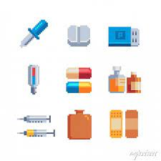

- Unneeded or unused over the counter medication (expired or not expired)
- Unneeded or unused prescription medication (expired or not expired)
- Can be dropped off in the bottle it came in or any other bag or container
- Sharps (lancets, syringes, etc.; must be in a rigid puncture-resistant container)

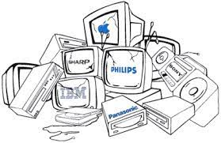
ELECTRONICS/COMPUTERS
Computers
Monitors
Printers/Scanners/Copiers
DVD Players
Including gaming systems that are able to play DVD’s)
CD Players
Stereo Equipment
VCR’s
Cell Phones
GPS Systems
Projectors
Fax Machines
Digital Photo Frames
Digital Media Players
iPods/MP3 Players
Camcorders/Cameras
DVR/TiVo Devices (Including cable boxes & satellite boxes)

TELEVISIONS
Regular - $20; Large- $25

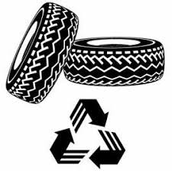
TIRES
Auto: Maximum of 12 per household First 4 Free
Next 8 - $2 each
Trucks: Maximum of 6 per household event First 4 Free
Next 2 - $5 each
Farm Tractor:
Whole - $75 each
Quartered - $5 (each - four quartered tires)

Restrictions: Only residents of Montgomery County are allowed to use the District’s Tox Away Day event. Regulations prohibit hazardous wastes from other organizations (businesses, churches, schools, non-profits, etc.) from being accepted. Please contact us if you have questions about your eligibility to participate in Tox-Away Day. Office: 765.361.2623 Email: mcswmd@montgomerycounty.in.gov

**Only cash or check will be accepted for payment**

